***1.Area of a rectangle***

***Algorithm:***

Step 1 : Start

Step 2 : Input value

Step 3 : Enter breath,length values

Step 4 : area = length*breath

Step 5 : print area

Step 6 : End

***Flow chart:***

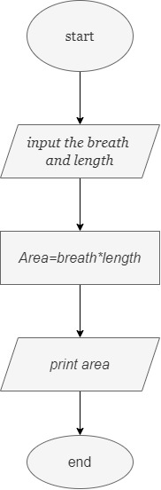

***Pseudocode:***

Beginning

Get breath and length

Calculate_area=length*breath

Display_area

End

***2.Calculate area and Circumference:***

***Algorithm:***

Step 1 : Start

Step 2 : input radius r

Step 3 : Area=3.14*r*r

Step 4 : Circumference=2*3.14*r

Step 5 : print Area and Cirumference

Step 6 : End

***Flow chart:***



***Pseudocode:***

Beginning

Get radius r

area=3.14*r*r

circumference=2*3.14*r

Display_area

Display_circumference

End

***3. Calculate Simple Interest:***

***Algorithm:***

Step 1 : Start

Step 2 : input p,n,r values

Step 3 : SI=p*n*r/100

Step 4 : print SI

Step 5 : End

***Flow chart:***

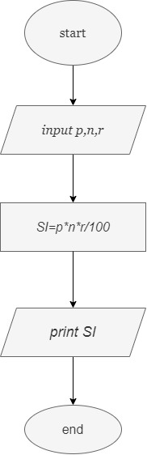

***Pseudocode:***

Beginning

Get p,n,r

SI=p*n*r/100

Display_SI

End

***4.Calculate engineering cutoff:***

***Algorithm:***

Step 1 : Start

Step 2 : input Mathematics(M),Physics(P),Chemistry(C)

Step 3 : cutoff=(P/4+C/4+M/2)

Step 4 :print cutoff

Step 5 : End

***Flow chart:***

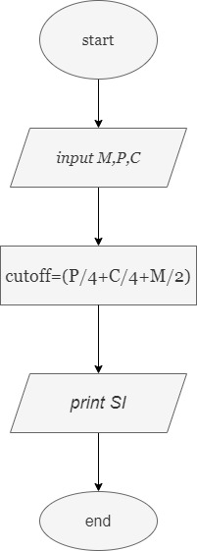

***Pseudocode:***

Beginning

Get Maths(M),Physics(P),Chemistry(C)

Calculate_cutoff=(P/4+C/4+M/2)

Display_cutoff

End

***5.greatest of two numbers:***

***Algorithm:***

Step 1 : Start

Step 2 : get A, B value

Step 3 : check if(A>B) print A is greatest

Step 4 : else B is greatest

Step 5 : End

***Flow chart:***

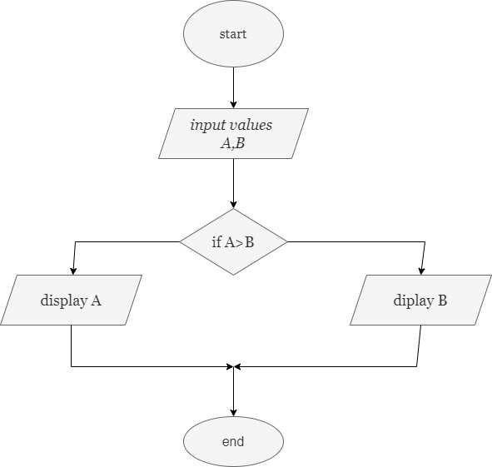

***Pseudocode:***

BEGIN

READ A, B

IF (A>B) Then

Display a is greatest ELSE Display b is greatest END IF

End

***6.check positive or negative number:***

***Algorithm:***

Step 1: Start

Step 2: get n

Step 3: check if(n>0) print n is positive

Step 4: if (n<0) print n is negative

Step 5:else print n is zero

Step 6: End

***Pseudocode:***

Begin

Read n

IF (n>0) THEN

DISPLAY n is positive

IF(n<0)

DISPLAY n is negative

ELSE n is zero

End

***Flow chart:***

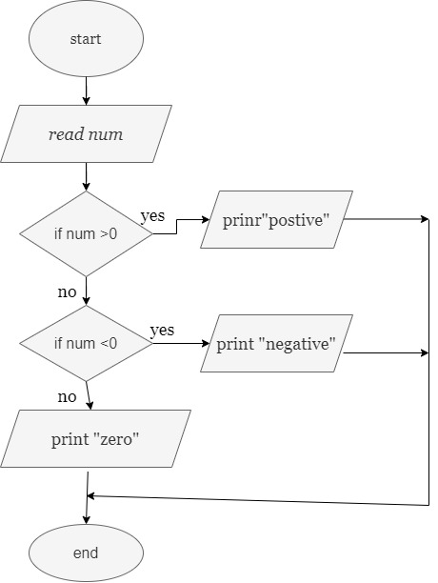

***7.Check odd or even number:***

***Algorithm:***

Step 1: Start

Step 2: Get N

Step 3: check if(N%2==0) print Number is even

Step 4: else Number is odd

Step 5: End

***Flow chart:***

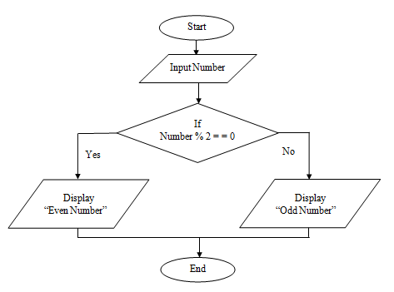

***Pseudocode:***

Begin

Read num

IF (num%2==0) THEN

DISPLAY num is even

ELSE

DISPLAY num is odd

End

***8.greatest of three numbers:***

***Algorithm:***

Step1: Start

Step2: Get A, B, C

Step3: if(A>B) and (A>C) print A

Step4: If(A<B) and(B>C)print B

Step5: else print C

Step6: End

***Flow chart:***

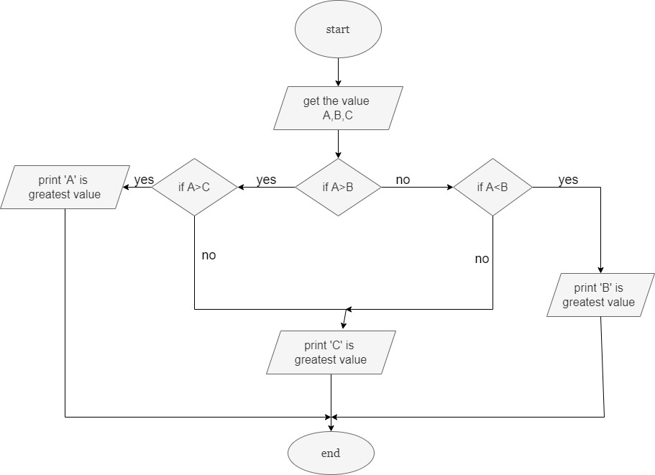

***Pseudocode:***

Begin

Read A,B,C

IF (A>B) and(A>C) Then

DISPLAY a is greater

IF(B>C) and(A>B)Then

DISPLAY b is greater

ELSE

DISPLAY c is greater

END IF

END IF

END

***9.check wheather given number +ve,-veor zero:***

***Algorithm:***

Step 1: Start

Step 2: Get n value.

Step 3: if (n ==0) then print “Given number is Zero”

Step 4: if (n > 0) then Print “Given number is +ve”

Step 5: else Print “Given number is -ve”

Step 6: End

***Flow chart:***

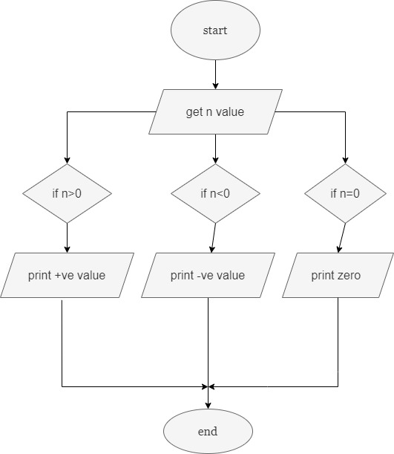

***Pseudocode:***

Begin

Get n

IF(n==0) Then

DISPLAY “ n is zero”

ELSE

IF(n>0) Then

DISPLAY “n is positive”

ELSE

DISPLAY “n is positive”

END IF

END IF

END

***10.prime all natural number up to n:***

***Algorithm:***

Step 1: Start

Step 2: get n value.

Step 3: initialize I=1

Step 4: while (I<=n) yes go to step 5 No End

Step 5: Print I value

Step 6: increment I value by 1

Step 7: go to step 4

Step 8: End

***Pseudocode:***

Begin

Get n

Initialize i=1

While(i<=n) DO

Print i

i=i+1

End

***Flow chart:***

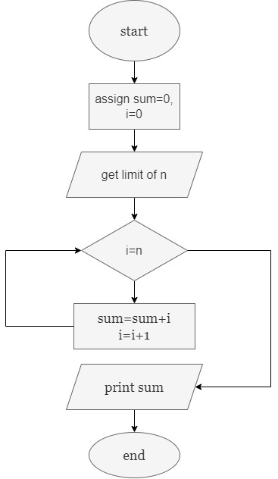

***11.print n odd numbers:***

***Algorithm:***

Step 1: Start

Step 2: get n value.

Step 3: initialize i=1

Step 4: while (i<=n) yes go to step 5 No end

Step 5: print i value

Step 6: increment I value by 2

Step 7: go to step 4

Step 8: End

***Flow chart:***

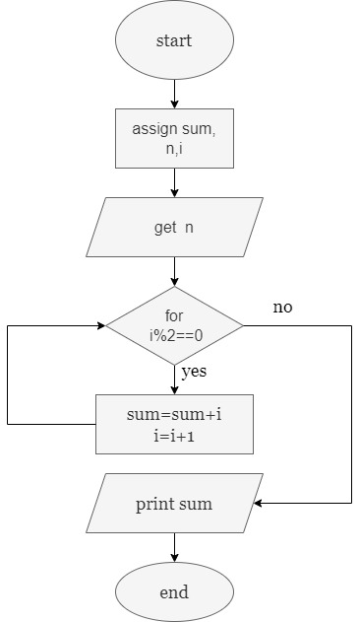

***Pseudocode:***

Begin

Get n

Initialize i=1

While(i<=n) DO

Print i

i=i+2

End

***12.print n even number:***

***Algorithm:***

Step 1: Start

Step 2: get n value.

Step 3: initialize I=2

Step 4: while (I<=n) yes go to step 5 no end

Step 5: Print I value

Step 6: increment I value by 2

Step 7: go to step 4

Step 8: End

***Pseudocode:***

BEGIN

GET n

Initialize i=2

While(i<=n) DO

PRINT i

i=i+2

End

***Flow chart:***

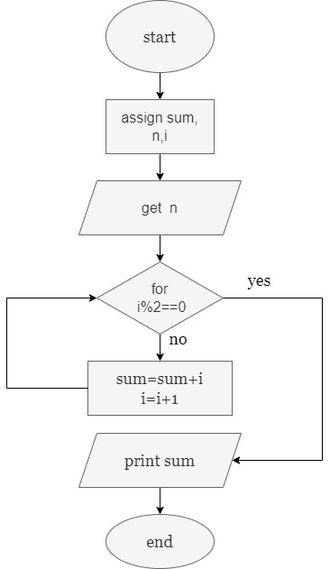

***13.Print squares of a number:***

***Algorithm:***

Step 1:Start

Step 2:get n value

Step 3:Initialize i=1

Setp 4: while(i*i) yes go to step 5 no go to print square

Step 5:square=i*i

Step 6:i=i+1

Step 7:print square

Step 8:End

***Flow chart:***

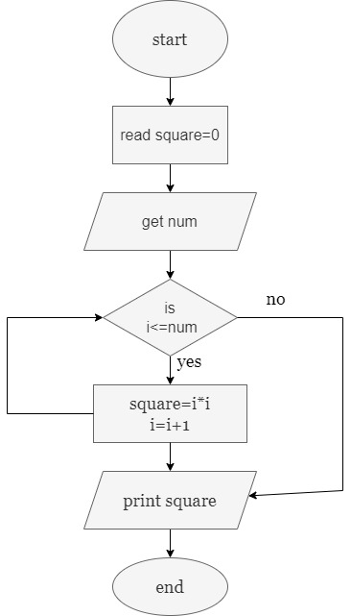

***Pseudocode:***

BEGIN

GET n

Initialize i=1

while(i<=n) DO

Print i*i

i=i+1

End

***14. print cubes of a number:***

***Algorithm:***

Step 1: Start

Step 2: get n value.

Step 3: initialize I=1

Step 4: while (I<=n) yes go to step 5 No End

Step 5: Print I*I*I value

Step 6: increment I value by 1

Step 7: go to step 4

Step 8: End

***Flow chart:***

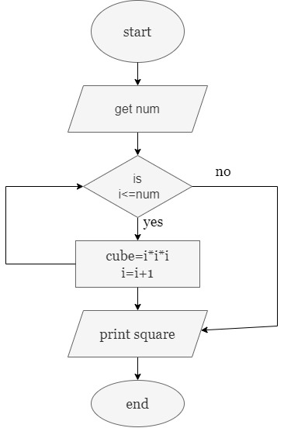

***Pseudocode:***

Begin

Get n

Initialize i=1

while(i<=n) DO

print i*i*i

i=i+1

End

***15.sum of given numbers:***

***Algorithm:***

Step 1: start

Step 2: get a and b values

Step 3:sum=a+b

Step 4:print sum

Step 5:End

***Flow chart:***

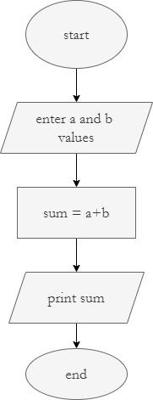

***Pseudocode:***

Begin

Get a and b value

Sum=a+b

Display sum

end

***16. factorial of a given number:***

***Algorithm:***

Step 1:Start

Step 2: Get n value

Step 3: initialize i=1

Step 4:while (i<=n) yes go to a step 5 no go to print fact

Step 5:fact=fact*i

Step 6:i=i+1

Step 7:print fact

Step 8:End

***Pseudocode:***

Begin

Get n value

Intialize i=1

while(i<=n)yes go to a next no go to a display fact

fact=fact*i

i=i+1

display fact

End

***Flow chart:***

